**How to Achieve Pull based mechanism:**

**Pull based mechanism are classified into 2 types**

**1.poll scm**

**2.Build periodically.**

1. Poll SCM job will be trigger based on the specific time if the project code was made change.

--> used will provide the cronjob for job builds like if user schedule job for every-minute then job will trigger within a minute when code changes are made.

Ex; ***** this crone job means job will trigger every-minute

User update some code then automatically job will trigger.

**Steps to Achieve POLL SCM:**

**Step-1:**

Here I am integrating github repository

$ sudo yum install git -y

**Step-2:**

Create on free style job [refer the previous document for job creation.]

**Step-3:**

1. Go to git and provide GitHub URL of repository where developer will be changing or updating.

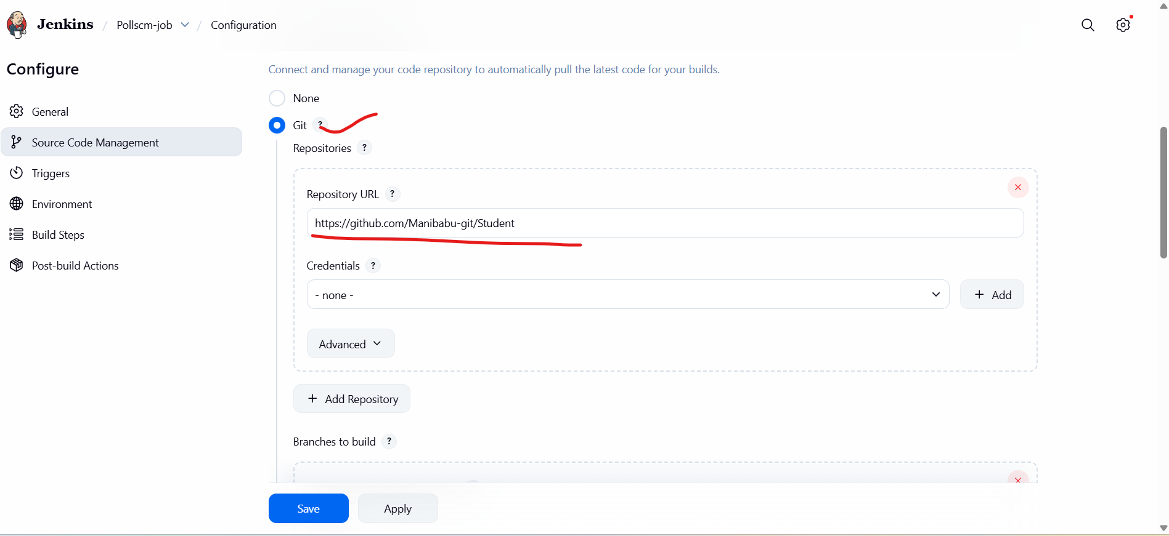

2.Provide the repository branch

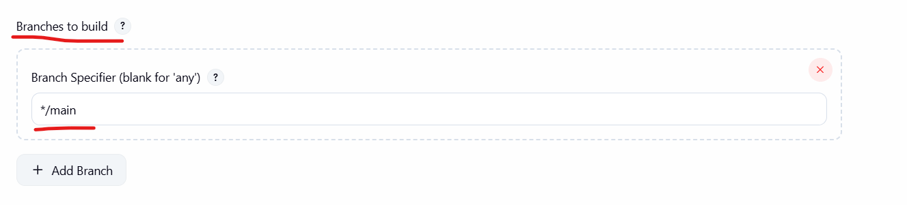

3.go to Triggers and select poll scm and provide schedule

Provide when the job will trigger after code changes made.

Note: if you want understand the crontab got to <https://crontab.guru/#>

4.do some changes in the repository.

Before changes made in the repo

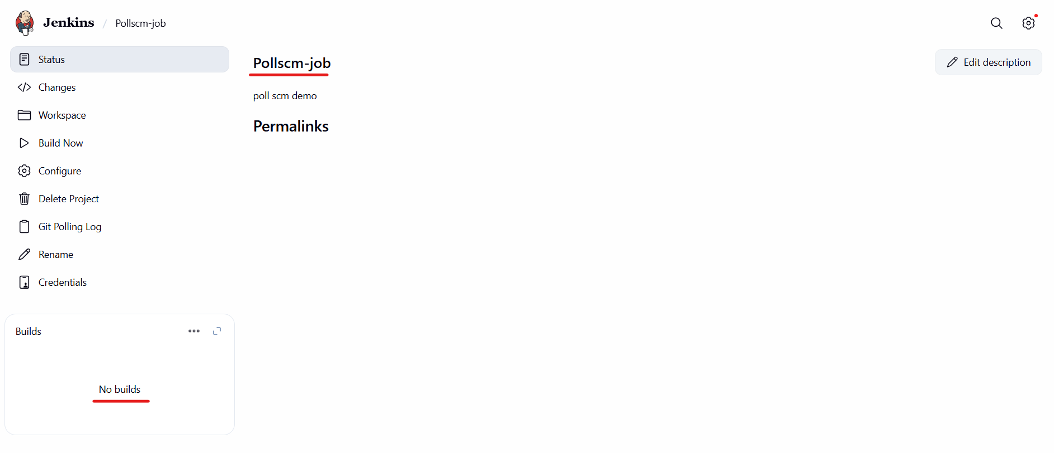

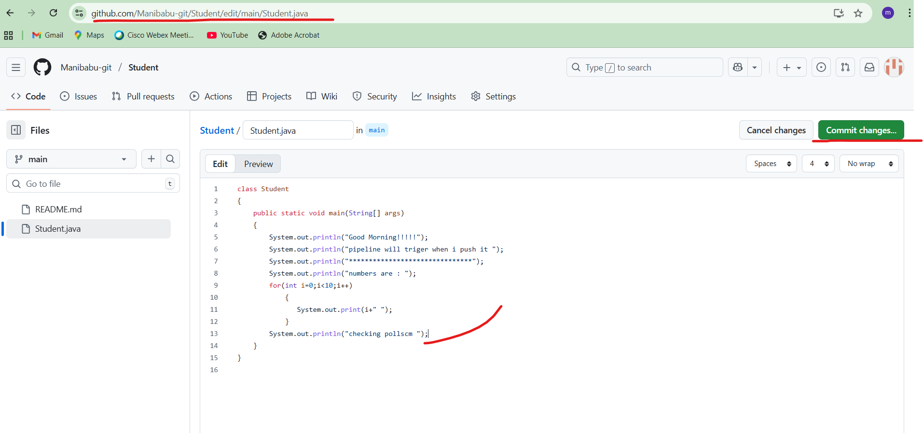the below job trigger automatically after made changes in the repo

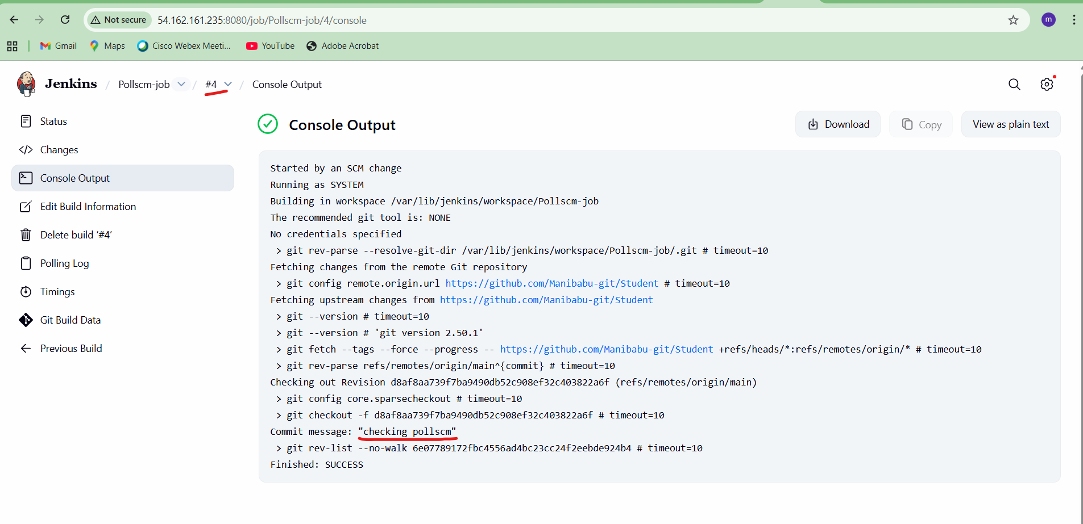

**2. Steps to Build periodically.**

Build periodically means job will be triggered based on the scheduled time .

This will not consider code changes.

